FINAL PROJECT REPORT

1. Project Overview
Client: Ridemate Mobility
Focus: Improve urban transit planning using real-time and predictive data analytics
Location: New York City
Business Problem: CitiBike stations often face unpredictable demand: some run out of bikes during peak hours, others remain unused for long periods. Similarly, subway turnstile traffic fluctuates based on time, weather, and local events. Ridemate needed a system to forecast transit demand and support proactive city responses.
Proposed Solution: Develop a Kafka-based real-time data ingestion pipeline paired with cloud-hosted PySpark and ETL pipelines for demand forecasting. This system streams data from multiple real-time sources and prepares it for downstream analytics and modeling.

2. Dataset Selection
Out of the datasets explored, we finalized the following three:
- CitiBike Trip Data: nyccitibike.csv
- MTA Subway Turnstile Data: MTA_Subway_Turnstile_Usage_Data__2022_20250510.csv
- NYC Safety Event Data: Safety_Events_20250510.csv
These datasets were selected for their influence on transportation demand and real-time availability.

3. Architecture Overview
Pipeline:
- Kafka Producers on GCP VM stream records in real-time from CSVs.
- Kafka Consumers on the same VM write these records into .jsonl files.
- Colab Notebook loads these .jsonl files for ETL and analysis.

4. Kafka Producer Scripts (Full Code)

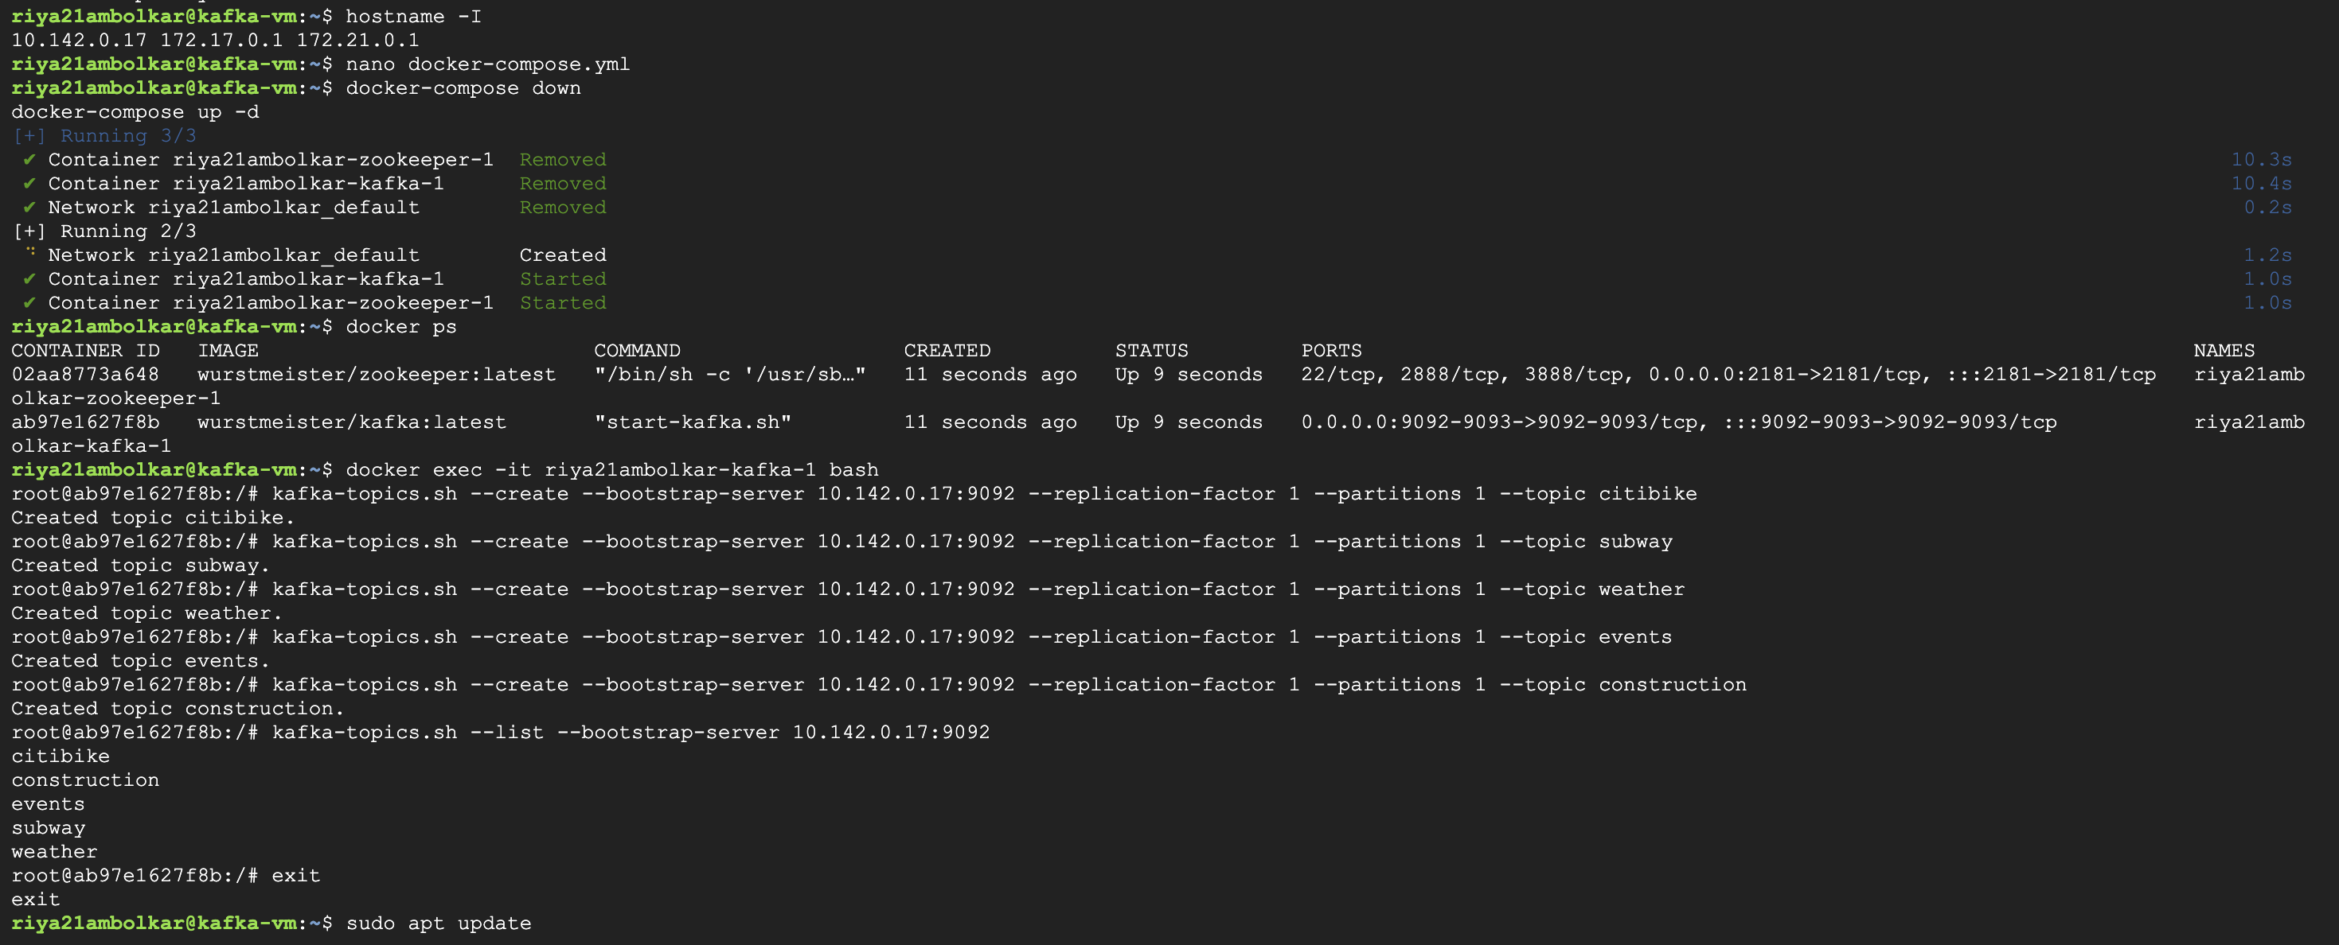

4.1 citibike.py

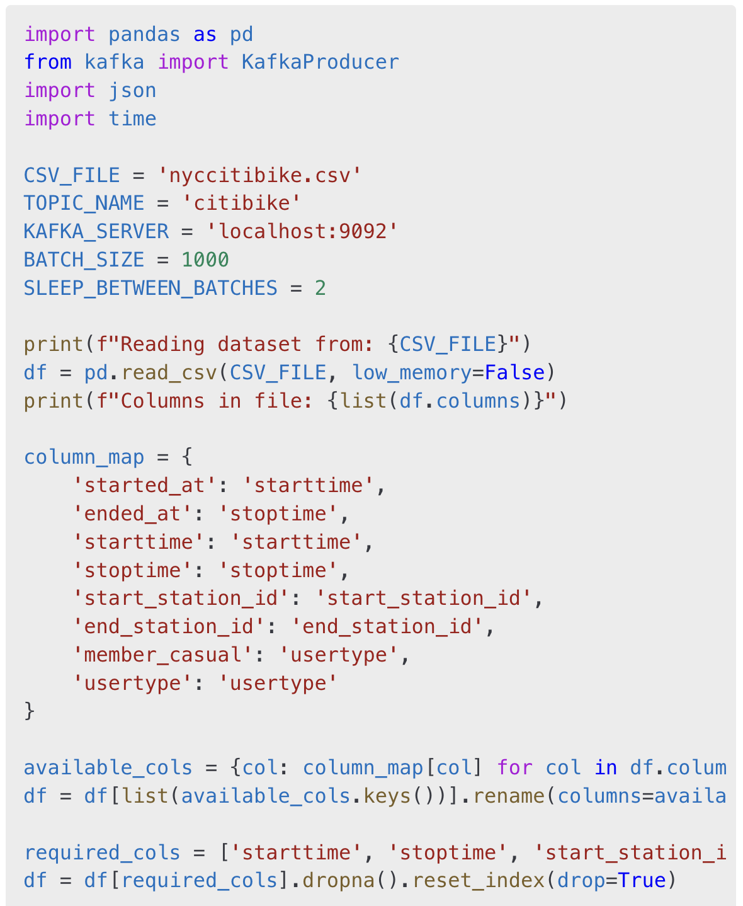

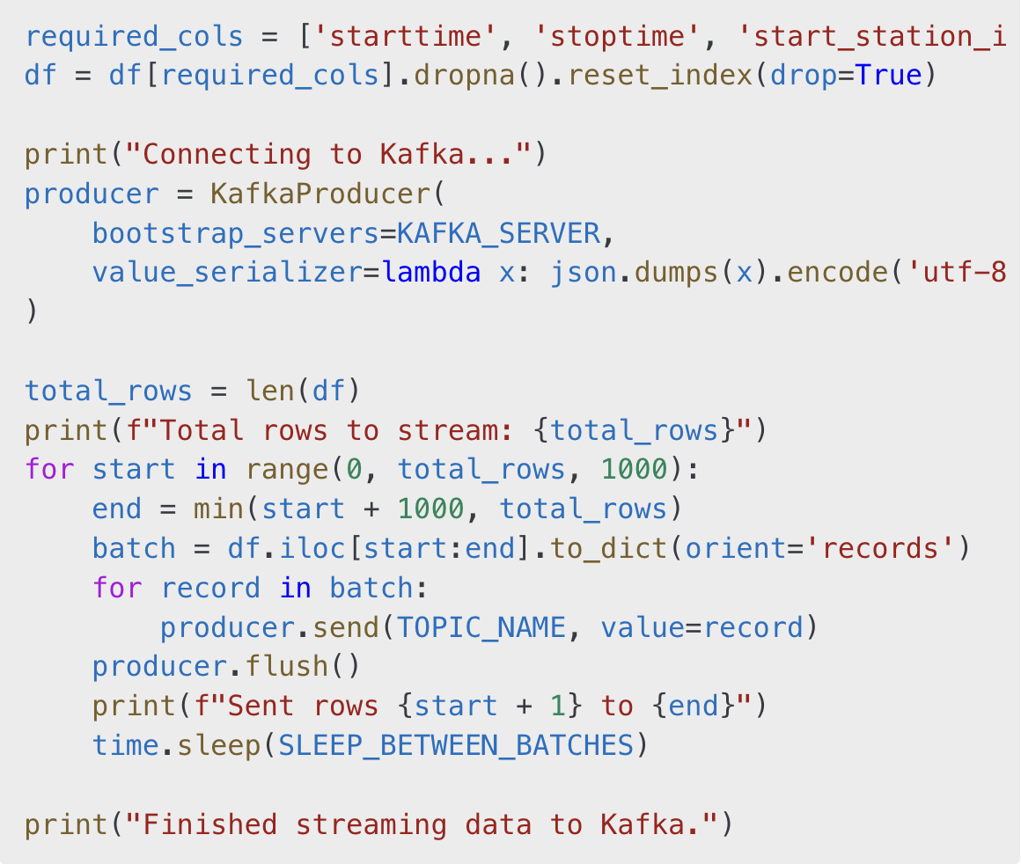

Output:

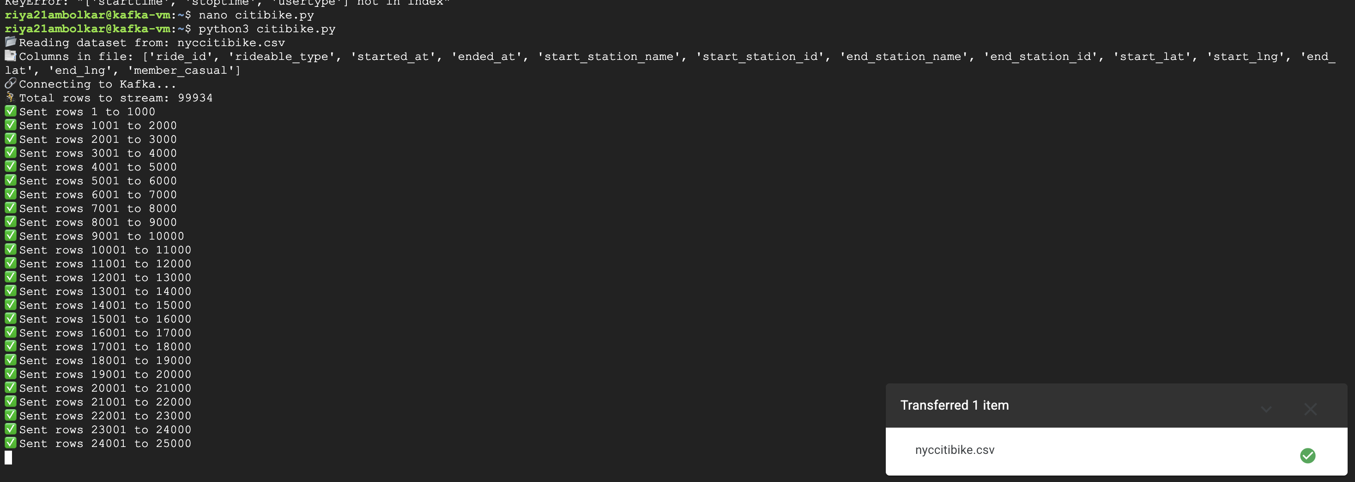

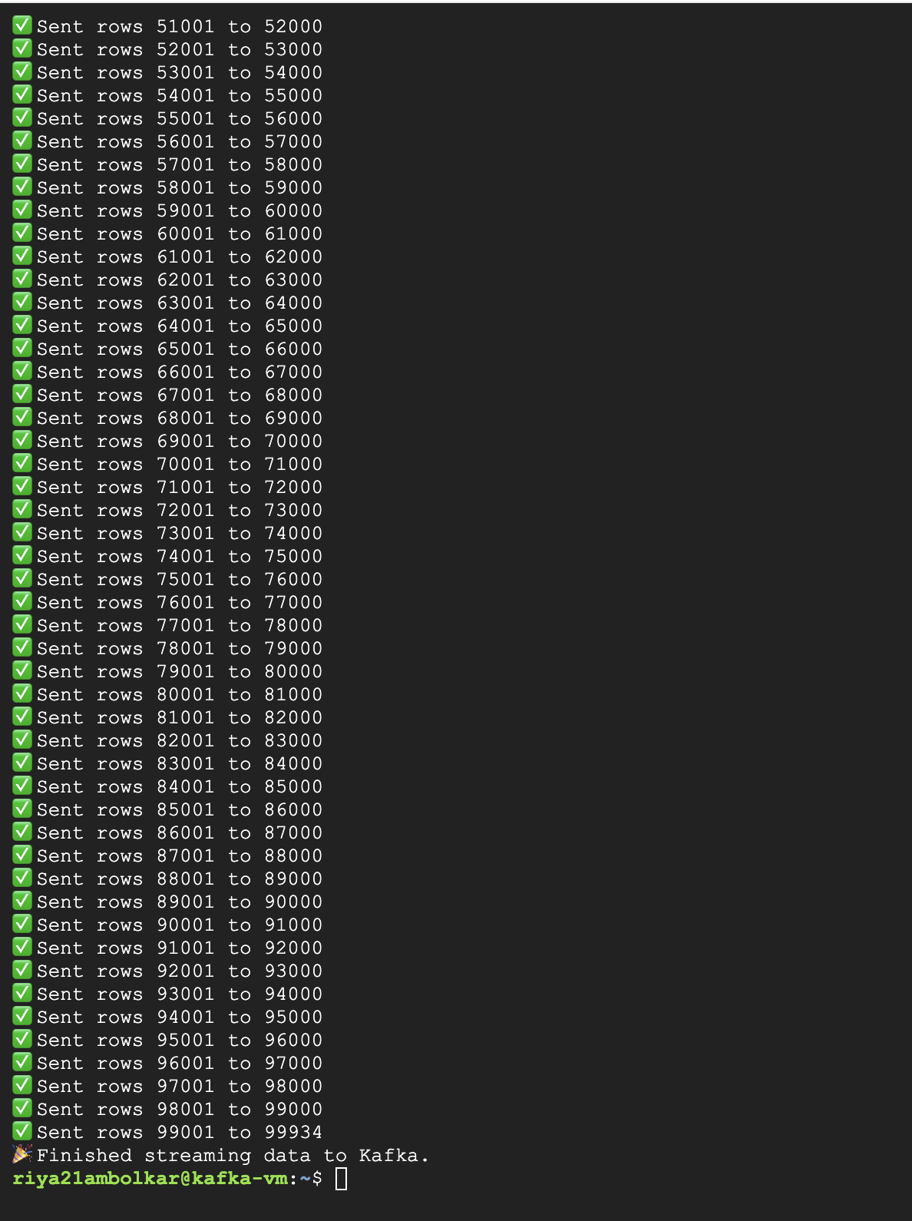

4.2 subway.py
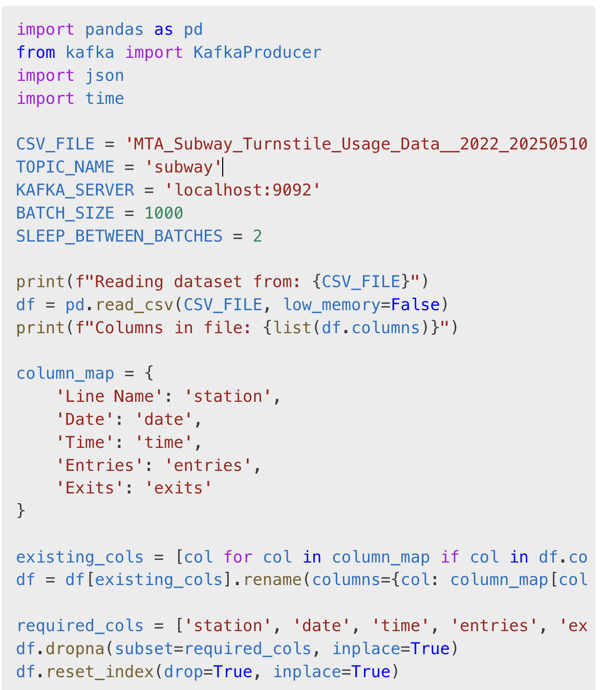
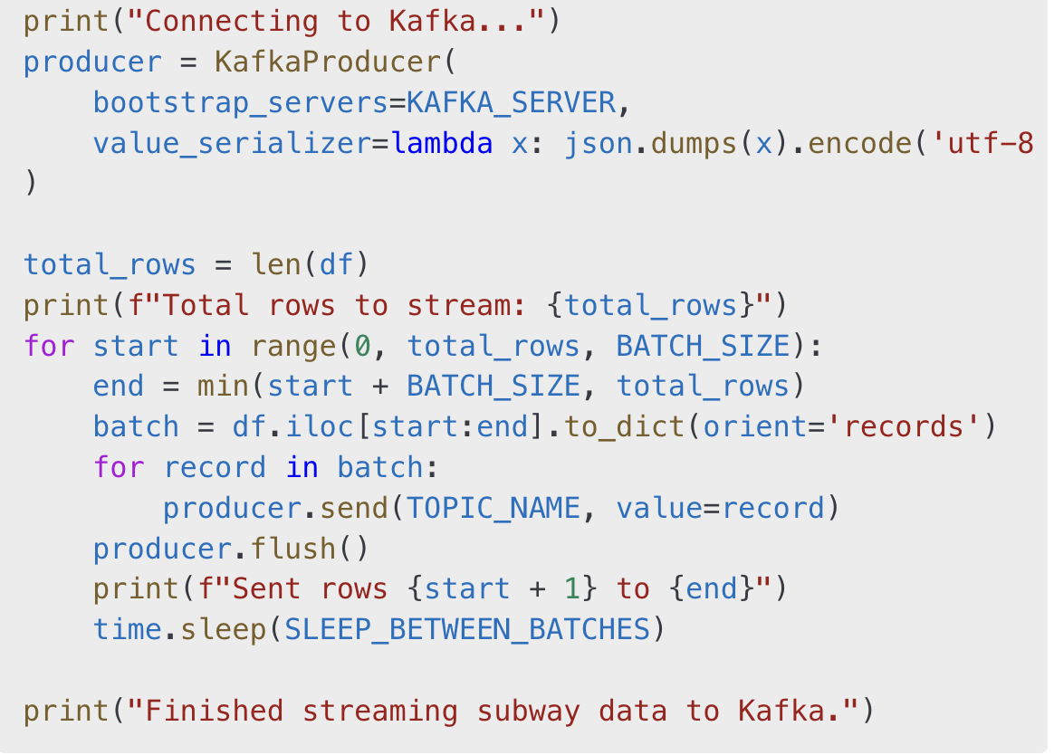
Output:
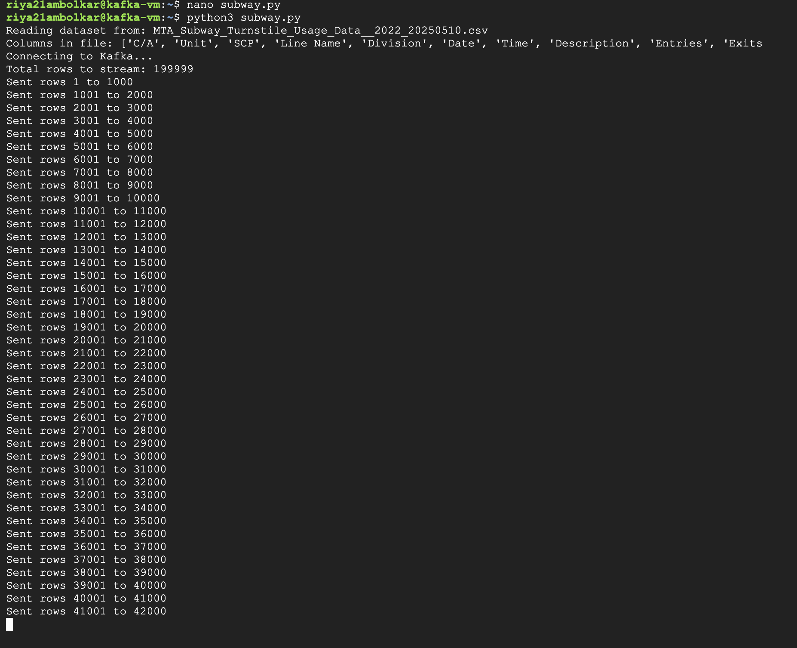
4.3 events.py
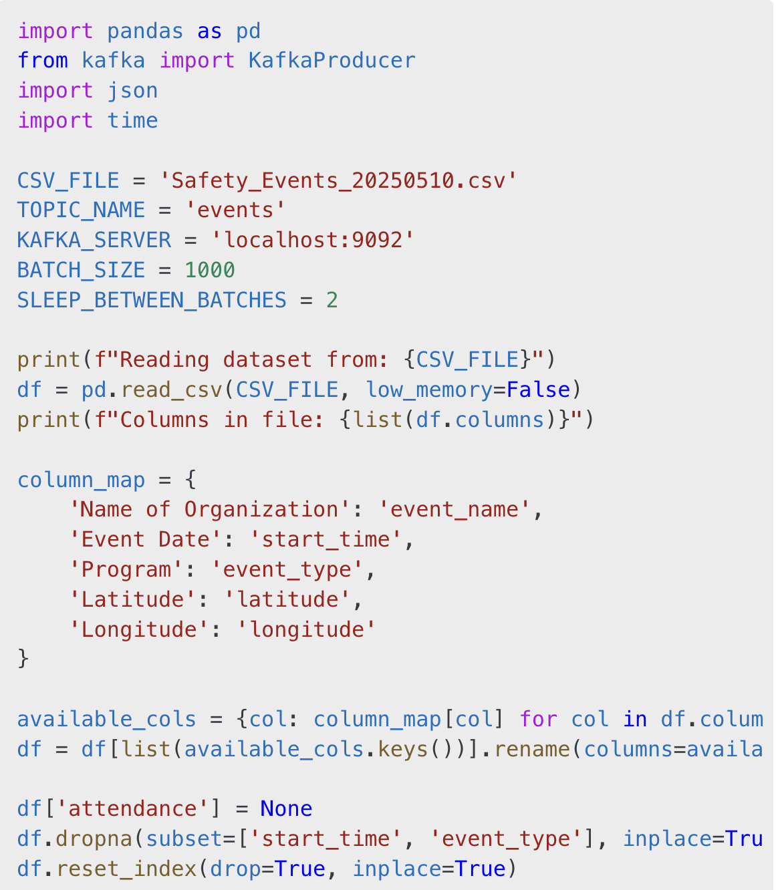
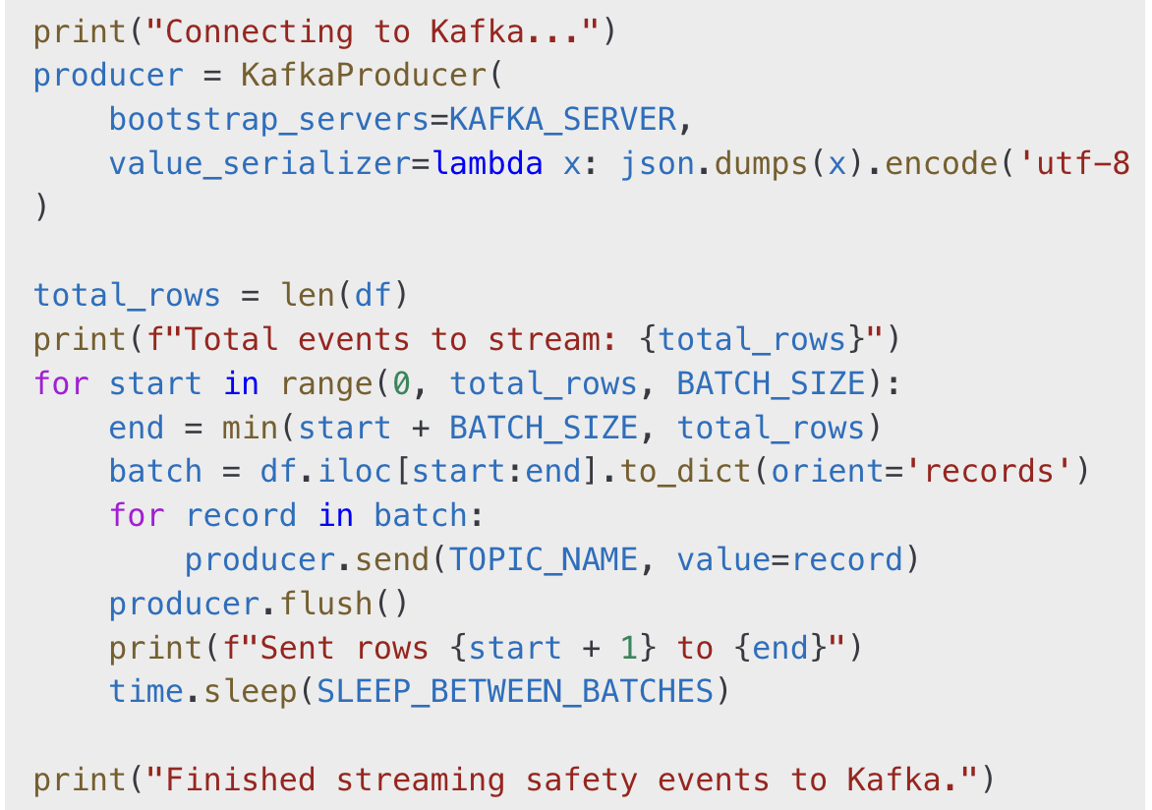
Output:
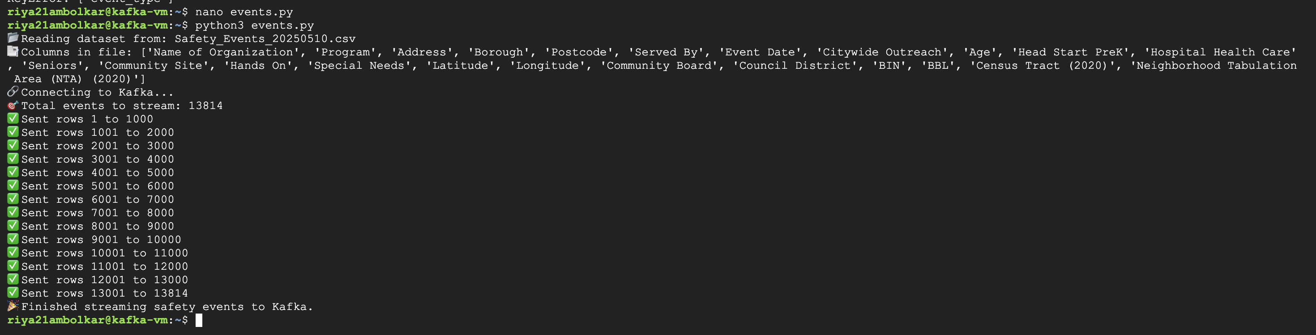

5. Integration with Google Colab using PySpark - Kafka Consumer Scripts
Initially, we attempted to connect Google Colab directly to our Kafka producers on the GCP VM using PySpark Structured Streaming. However, due to persistent connectivity issues, buffering problems, and JVM stream timeouts within the Colab environment, this direct streaming approach was not feasible.
To overcome these limitations, we adopted a more reliable alternative:
- Kafka producer scripts were retained on the GCP VM.
- Kafka consumer scripts were created to write streamed messages to local .jsonl files for each dataset.
- These .jsonl files were downloaded to the local system and uploaded into Google Colab.
- Inside Colab, we used PySpark to parse, structure, and analyze the data.

5.1 citibike_consumer_to_file.py
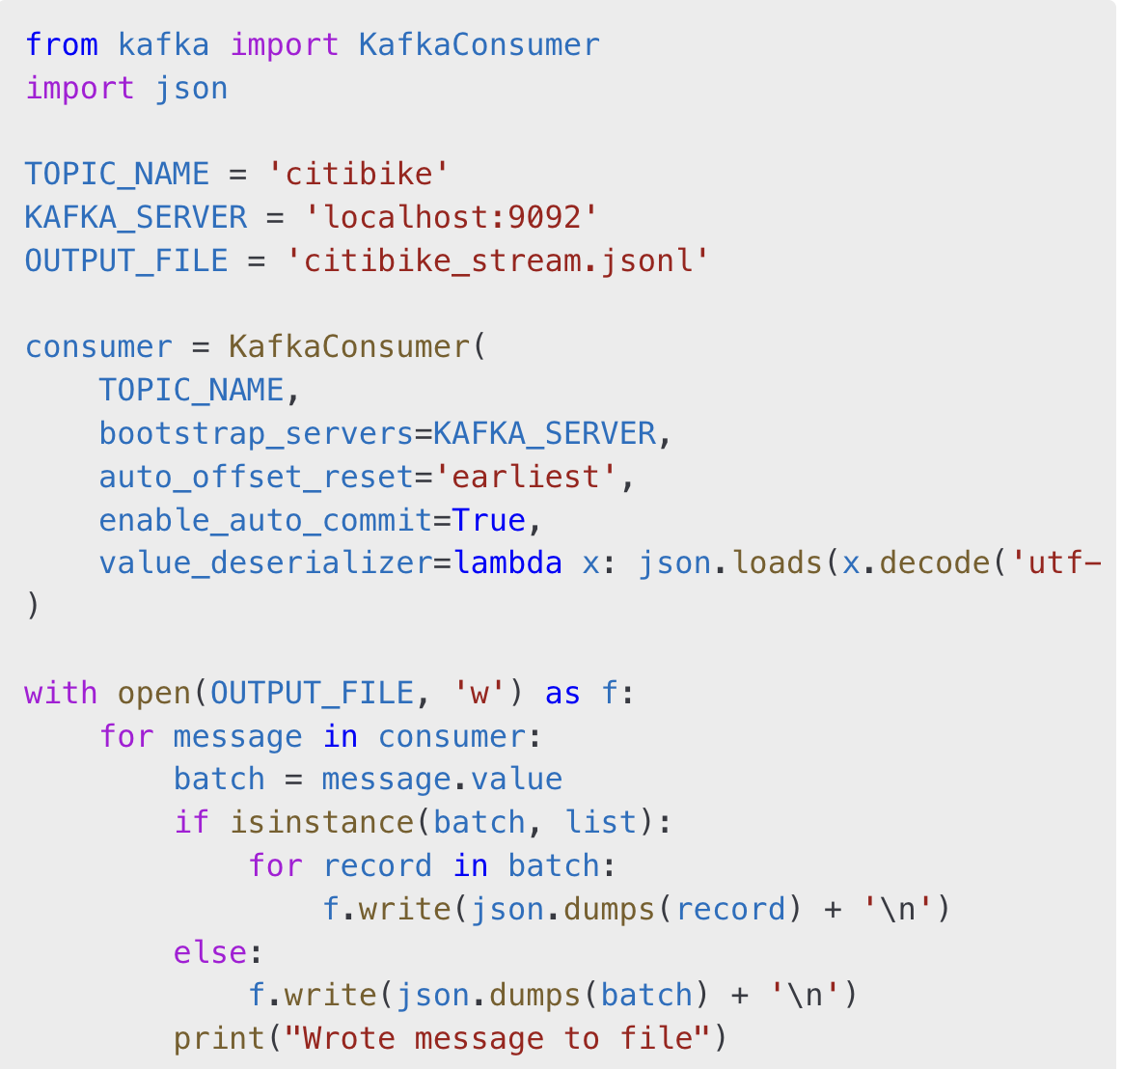
Output:
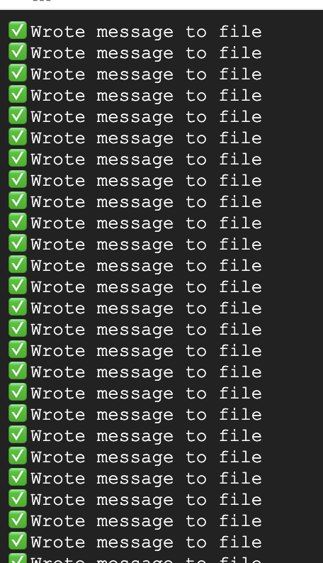
5.2 subway_consumer_to_file.py
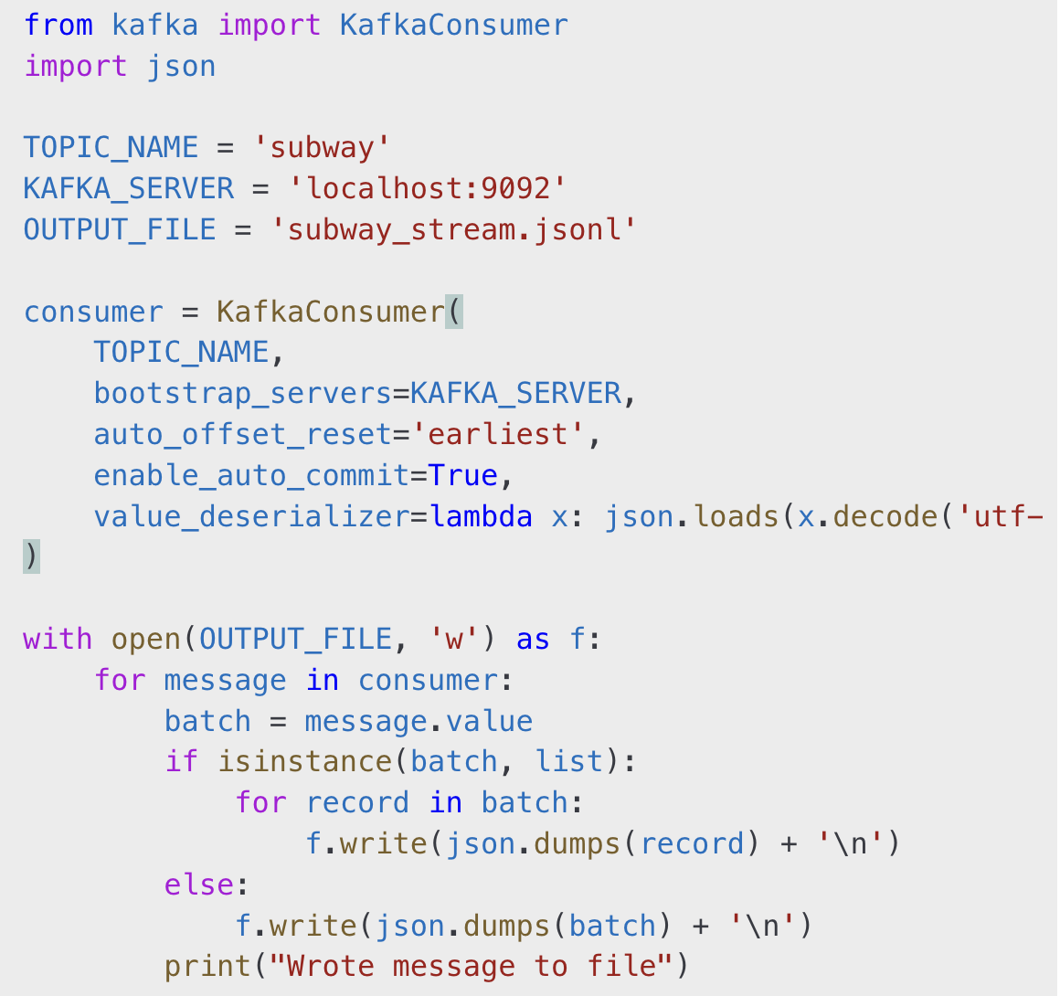
Output:
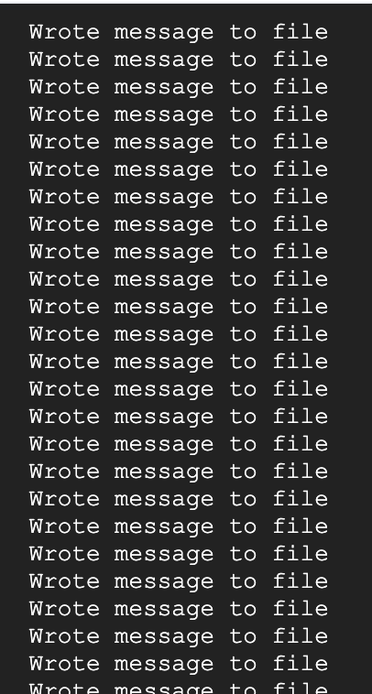
5.3 events_consumer_to_file.py
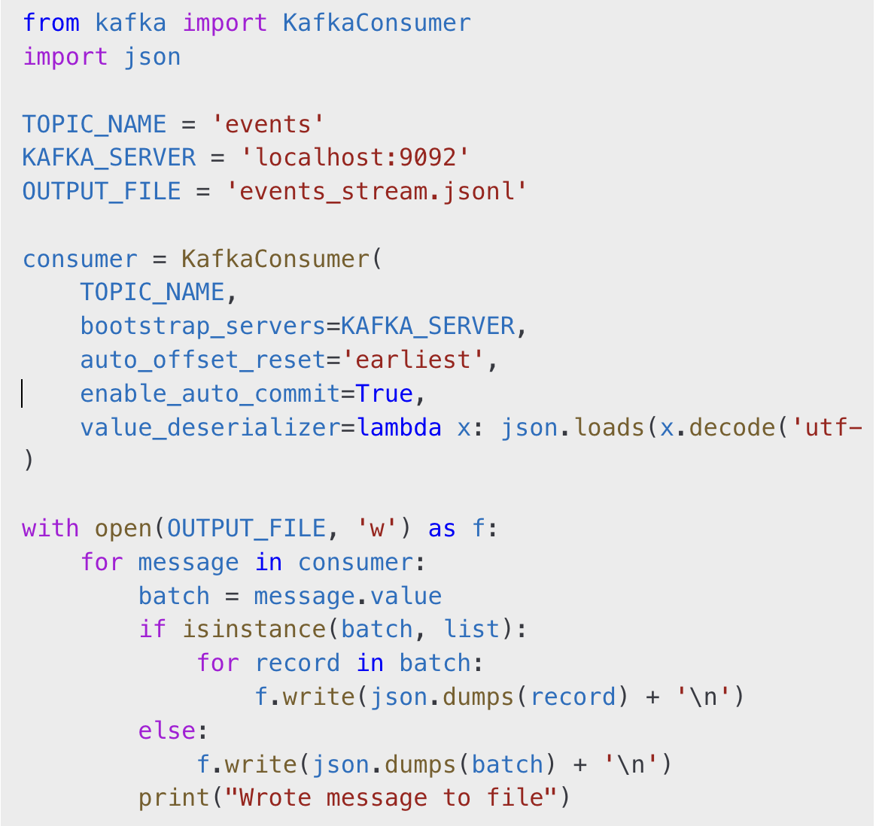
Output:


